Jollibee: Should They Enter the UK Market?
Katherine Garrity
Edinburgh Napier University
5 March 2014

Contents
- Introduction……………………………………………………………………….3
- Situation Analysis
2.1 Fast Food Industry ………………………………………………………….3
2.2 External Analysis
2.2.1 Demographics/ Niche Audience………………………...3-4
2.2.2 PESTLE……………………………………………………4-5
2.2.3 Porter’s Five Forces………………………………………5 -6
2.3 Internal Analysis
2.3.1 Brand Image………………………………………………6-7
2.3.2 Mission and Values……………………………………….7
2.3.3 SWOT………………………………………………………7-8
- Current Position
3.1 Porter Generic Strategies……………………………………………………8
3.2 Product Life Cycle…………………………………………………………….9
- Strategic Concerns………………………………………………………………..9-10
- Recommendations
5.1 Short Term ……………………………………………………………………10
5.2 Long Term……………………………………………………………………..10
- Conclusion………………………………………………………………………….10-11
- References
- Appendices
8.1 Appendix 1……………………………………………………………………..20-22
8.2 Appendix 2……………………………………………………………………..22-29
8.3 Appendix 3……………………………………………………………………...29
8.4 Appendix 4……………………………………………………………………...29-30
8.5 Appendix 5……………………………………………………………………...30-36

- Introduction
“Jollibee is the dominant fast food restaurant chain the Philippines with over 60 percent of the market share” (Gillespie and Hennessey, 2011). Jollibee has been most successful in the Filipino market due to its customer and company base in the country itself. “Currently, Jollibee has a total of 765 stores in the Philippines, 39 in Vietnam, 13 in Brunei, 27 in the United States, 8 in Jeddah, three in Qatar and one each in Hong Kong, Kuwait and Singapore” ( Samaniego, 2013). Known for its focus on family, customers, and quality of service, Jollibee has developed its presence in the daily lives of Filipino families. Jollibee is a major figure of pride and success for Filipinos everywhere because of the humble nature that Jollibee’s success stemmed from (Jollibee, 2014a). The present question being facing by this Filipino giant is whether or not Jollibee should enter the UK market. Through the analyses conducted throughout this report, the answer to this question will become quite clear.
- Situation Analysis
  - Fast Food Industry Overview
The fast food industry has been an extremely competitive market globally for decades.
“Major companies include US-based giants Doctor's Associates (Subway), McDonald's, and YUM! Brands (KFC, Pizza Hut, Taco Bell), as well as Café de Coral (Hong Kong), Greggs (UK), Jollibee Foods (the Philippines), and Seven & i Food Systems (Japan) “ (Fast Food and Quick Service Restaurants Report Summary, 2014).
Fast food consumption has been steadily increasing despite global events such as economic downturns as well as health issues making national news such as the obesity epidemic. “In 2012, market research suggests that consumers are eating out more often than in the previous two years” (Nobel House, 2012).
  - External Analysis
    - Demographics
Jollibee’s success is almost entirely due to the Filipino population. Jollibee has its company base in the Philippines, the entire board of directors is Filipino, and most of Jollibee’s stores are located within the Philippines.
“According to company officials and food experts, Jollibee owes its success to the fact that it respects local tastes. Unlike McDonald's, Jollibee was flexible…Jollibee had this big marketing campaign that appealed to Filipino sentiment" (Conde, 2005).
With this in mind, the question to ask is whether or not the United Kingdom possesses a large Filipino population to kick start Jollibee’s success in Europe. The Office for National Statistics ranked the population by country of birth and nationality for the entire United Kingdom. According to the data gathered by the Office for National Statistics, the Philippines ranked 16th for most common country of birth out of 60 countries being considered and ranked 18th for the most common nationality out of the same 60 countries. The small amount of Filipinos in the UK might not be enough to fuel the launch of Jollibee in such a competitive market.
Table 1: Most common countries of birth and nationalities in the UK (Office For National Statistics, 2013).
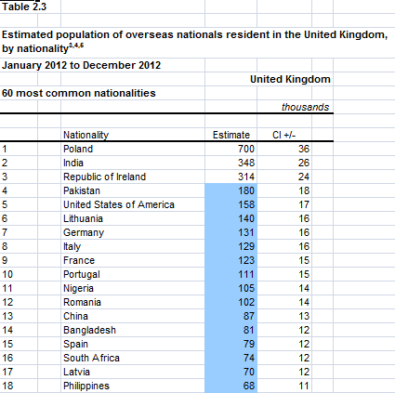
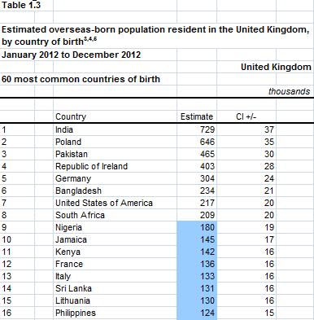

    - PESTLE
The PESTLE framework analyzes six different aspects of society that structure the environment in which a business is operating. Having knowledge about each of these areas is crucial in developing a successful business strategy. The environment Jollibee needs to consider in this PESTLE framework is the United Kingdom.
Figure 1: main points in PESTLE; original creation of figure.
    - Five Forces Model
Porter’s Five Forces Model focuses on the five forces that affect a given business or industry. Within the fast food industry, the rivalry amongst competitors is extremely intense and high. The threat of new entrants is low to medium because of the fact that there are so many major global brands dominating the fast food industry. The threat of supplies is low because there are many different suppliers in the fast food industry. The threat of substitute products is very high due to the fact that there are masses of options available. Buyers of food are in control and have a high bargaining power. “The collective strength of these forces determines the ultimate profit potential of an industry” (Porter, 1979).

- Global brands dominating industry
- Established customer base and loyalty
- Consumer preferences and taste changes
- Brand recognition
- Potential costs

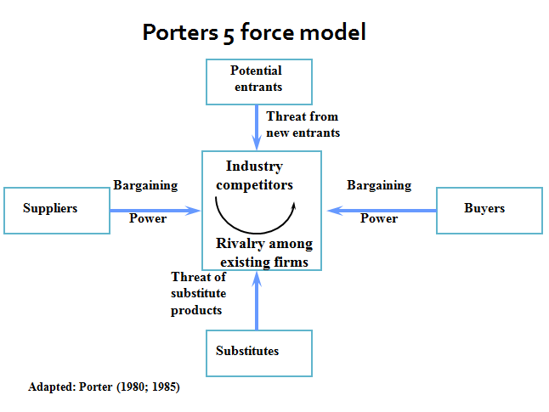

- Many suppliers
- Existing contracts with suppliers?
- Companies have more bargaining power depending on size of company
- Many options available
- Price sensitive
- Many market segments

- Many alternatives and substitutes available
- Price has a role
- Differentiated products
- Brand loyalty
- Convenience

Figure 2: Five Forces Model of the Fast Food Industry (Porter, 1980;1985)
  - Internal Analysis
    - Brand Image
Jollibee’s brand image is extremely positive amongst its loyal customers. Jollibee understands the power that consumers possess and the return that stakeholders will earn as a result of the patronage of loyal customers (Jollibee Foods Corporation, 2003). In addition to appealing to the Filipino culture, Jollibee has been involved with organizations and causes that benefit society. Jollibee Foods Corporation donated millions of dollars in relief efforts towards the victims of Typhoon Yolanda back in 2013 (Umbao, 2013). Jollibee has also been in partnerships with the Sa Aklat Sisikat Foundation to help children read and love reading (Jollibee Foods Corporation, 2003). In essence, Jollibee customers are not looking for just food, they are looking at a close knit community and brand that has the same values they do (Jollibee: A Taste of Home for Filipinos, 2012). Kotler et al. (1996) explained how companies must see how a brand is more than just a name. Kotler describes the challenge of branding as developing a sense of meaning of a brand that aligns with what the consumers believe and value in the brand (Kotler et al., 1996).
    - Mission and Values
Jollibee’s mission statement is as follows, “To serve great tasting food, bringing the joy of eating to everyone” (Jollibee, 2014). They value things such as customer focus, excellence, family, and other principles that apply to their mission statement. As defined by Isobel Doole and Robin Lowe in International Marketing Strategy, values are the indicators consumers use to serve as guides for what is appropriate behavior (Doole & Lowe, 2012). Compared to major competitors such as McDonalds, Jollibee is much more community oriented. McDonalds’ mission statement focuses on being the customer’s favorite place to eat and want to use the 4P’s approach to achieve global dominance (McDonalds, 2014). McDonalds’ global dominance in the fast food industry raises concerns relating to the potential success that Jollibee could achieve if they appeal to mainly Filipino persons rather than the whole world’s population.
    - SWOT
The SWOT analysis examines the strengths, weaknesses, opportunities and threats facing a given entity (Doole & Lowe, 2012). Applying SWOT to Jollibee gives insight into what the brand is facing presently. Jollibee’s biggest strength is its loyal customers and brand image. Jollibee’s biggest weakness would also be its biggest strength—the Filipino population; this is because Jollibee is so dependent on this specific group of people for success. Jollibee’s biggest opportunity is the potential to grow and expand globally. Lastly, Jollibee’s biggest threat would be its competitors; the fast food industry is very saturated with many companies, all of different offerings and strength within the market.
Strengths  - Brand image is excellent amongst loyal customers and in the industry  - Culturally adaptive (i.e. to the Filipinos)  - Family and customer focused  - Continued financial success  - Dominant chain in Philippines  - Niche market is defined | Weaknesses  - Dependent on Filipino population  - No base in Europe  - Global presence not on par with competitors such as McDonalds or Yum! Brand
Opportunities  - Grow globally  - Social media marketing/use of technology  - Unique product offerings/ being different than major global brands such as McDonalds. | Threats  - Competitors  - Bargaining power of consumers  - Health epidemics such as obesity  - Healthy lifestyles and eating habits on the rise
Figure 3: SWOT Analysis main points; original creation of figure
- Current Position
  - Porter Generic Strategies
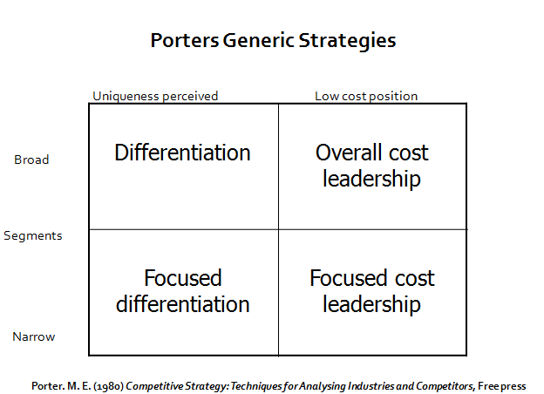
The generic theories developed by Porter are three broad strategies that develop the position one company has relative to others in a given industry (Porter, M. E, 1980). This advantage is established through three means: cost leadership, differentiation, or by focus (Cambridge Business English Dictionary, 2014). Jollibee has taken the focused differentiation approach. Jollibee’s products are very unique and unusual compared to that of its competitors such as McDonalds, Subway, and Greggs. Jollibee possesses a Filipino flair added to all of their products making it a very specialized menu versus a generalized menu that is common in the fast food industry.

Figure 4: Porter’s Generic Strategies Model (Porter, 1980)
  - Product Life Cycle
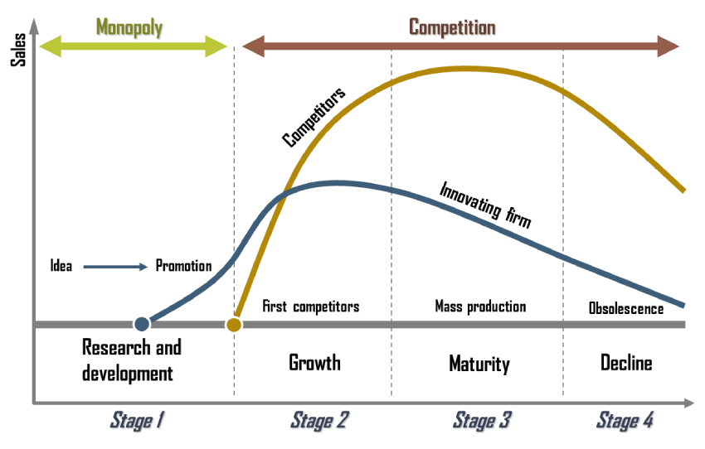
Product life cycle is the stages a product, business, or industry goes through over the course of its operating life. The stages of the product life cycle include: introduction, growth, maturity, and decline. The main competitors of the fast food industry can also be indentified according to their life stages. Jollibee, having a well known presence in the Philippines, is still experiencing growth in international sectors such as China and the U.S. McDonalds is at the maturity stage of their life cycles; growth is almost impossible since they have already spread internationally. Popular U.S. chain, Boston Market, is on the decline, having experienced massive amounts of store closings throughout the U.S.

Figure 5: Product Life Cycle Model (People.hoftra.edu, 2014).

- Strategic Concerns
There are several strategic concerns surrounding the potential entrance of Jollibee into the UK market. The first concern is the amount of competitors in the fast food industry. As stated before, the fast food industry is extremely saturated and full of companies and brands that offering different products. McDonalds currently holds the most market share in this industry followed by brands such as Yum! Brands and Doctor’s Associates (Fast Food and Quick Service Restaurants Report Summary, 2014). This raises the question, is there room for Jollibee in the UK market when there are such dominant brands? The next concern is the bargaining power of consumers. Bargaining power is high due to the fact that the switching costs between fast food choices are low (Wilkinson, 2013). Another concern facing Jollibee is the obesity epidemic. Fast food consumption has played a major role is increasing the rate of obesity due to food takeaways containing high levels of salt and fat (Public Health England, 2013). In conjunction with the topic of obesity, healthier lifestyle choices are becoming more apparent which could prove difficult for a fast food brand such as Jollibee (The National Health Service, 2014).

- Recommendations
  - Short Term Recommendations
The short term recommendations for Jollibee revolve around Jollibee developing its full potential to become the next global player in the fast food industry. While Jollibee has had success in emerging economies such as the Philippines, launching its brand in such an established economy, the United Kingdom, raises concerns. The reception of Jollibee in the United Kingdom could very well determine its fate in the entire international market. Jollibee needs to gain insight into the culture of the UK through market research. Jollibee Foods Corporation needs to understand the opportunities that exist in the UK market segment as well as learn about how to adapt to this slow diffusion culture.
  - Long Term Recommendation
The long term recommendations for Jollibee concern the market entry strategy into the UK. In the past, Jollibee has used franchising, acquisition, and joint ventures to expand globally. This is evident through the franchising of Jollibee and Chow King stores throughout Asia and the Middle East (Jollibee, 2014a). Jollibee acquired Greenwich Pizza and has continued to grow that brand. Jollibee also has a joint venture with Deli France which has continued success (Jollibee Foods Corporation, 2003). The recommended strategy for entry into the UK would be through joint venture. A joint venture could be possible with companies such as Burger King. Burger King was hit hard by the recent horse meat scandal and has been struggling to pick sales up ever since.
- Conclusion
Jollibee is a very successful business that has been experiencing major growth; however, they have intense competition to be faced if they are to become a major global competitor in the fast food industry. After conducting the various analyses of Jollibee and the fast food industry in general, I have come to the conclusion that Jollibee should enter the UK market, but not alone. Jollibee should enter a joint venture with a business, such as Burger King, that is on the decline and needs assistance kick starting their sales again. Since Burger King has been established in the UK for a while, they can offer insight into the culture and operating of the United Kingdom’s fast food industry as well as consumer behavior. Preferences of consumers seem to be swaying towards Asian influenced foods, as shown in Appendix 2, which is an extremely valuable opportunity for Jollibee to take advantage of. Jollibee has experience and major success with joint ventures in the past, as evident with Deli France, so a joint venture in the UK market seems like the best option for this growing brand and company.

- References

About McDonalds. 2014. About McDonalds. [online] Available at: http://www.aboutmcdonalds.com/mcd/our_company.html [Accessed: 25 Feb 2014].
BBC News. 2013. Developing world obesity quadruples. [online] Available at: http://www.bbc.co.uk/news/health-25576400 [Accessed: 25 Feb 2014].
Billionaire Tony Tan Caktiong Takes Jollibee Foods Global. 2013. Forbes: Forbes Asia, Available at: http://www.forbes.com/sites/forbesasia/2013/01/30/billionaire-tony-tan-caktiong-takes-jollibee-foods-global/2/ [Accessed: 10th February 2014].
Bloomberg Businessweek. 2014. JOLLIBEE FOODS CORPORATION (JFC:Philippine Stock Exchange): Financial Statements - Businessweek. [online] Available at: http://investing.businessweek.com/research/stocks/financials/financials.asp?ticker=JFC:PM [Accessed: 24 Feb 2014].
Bloomberg Businessweek. 2014. JOLLIBEE FOODS CORPORATION (JFC:Philippine Stock Exchange): Earnings Estimates - Businessweek. [online] Available at: http://investing.businessweek.com/research/stocks/earnings/earnings.asp?ticker=JFC:PM [Accessed: 24 Feb 2014].
Boseley, S. and Campbell, D. 2013. Food industry playing for time on regulation, says obesity expert. The Guardian, 19 February 2013.
Butler, S. 2013. Quarter of Consumers Prepared to Buy Green Even If it Costs More Money. [online] 20 August 2013. Available at: http://www.greenwisebusiness.co.uk/news/quarter-of-consumers-prepared-to-buy-green-even-if-it-costs-more-money-4061.aspx#.Uv4JsfmwL-s [Accessed: 25 Feb 2014].
Cadieux, D. and Conklin, D. 2010. The Great Recession, 2007-2010: Causes and Consequences. Harvard Business Review, Available at: http://hbr.org/product/the-great-recession-2007-2010-causes-and-consequen/an/910M08-PDF-ENG [Accessed: 27 Feb 2014].
Communications Market Report: A Nation Addicted to Smartphones. 2011. Ofcom, Available at: (http://consumers.ofcom.org.uk/2011/08/a-nation-addicted-to-smartphones/ [Accessed: 25 Feb 2014].
Conde, C. H. 2005 “Jollibee Stings McDonalds in Philippines” The New York Times. 31st May 2005.
De Angelis, A. 2013. Global fast food restaurant industry to increase by 4.2% per year through 2018. companiesandmarkets.com, Available at: http://uk.finance.yahoo.com/news/global-fast-food-restaurant-industry-000000514.html [Accessed: 10th February 2014].
Department for Environment, Food, and Rural Affairs. 2006. Food Industry Sustainability Stratgey. [report] London: FISS Secretariat.
Department for Environment, Food, and Rural Affairs .2012. Food Statistics Pocketbook 2012. London.
Department for Environment, Food, and Rural Affairs. 2013. UK's Carbon Foorprint 1997-2011. [report].
Doole, I. and Lowe, R. 2012. International Marketing Strategy: Analysis, Development, and Implementation, Sixth Edition. Hampshire; Cengage Learning.
European Union: European Social Fund. n.d. Sustainable development. [online] Available at: http://www.dwp.gov.uk/esf/resources/sustainable-development/ [Accessed: 25 Feb 2014].
“Fast Food and Quick Service Restaurants Report Summary”, Hoover’s, Inc., accessed 10th February 2014.
Filipinos 2nd largest Asian group in US, census shows. 2012. [online] 25 March 2012. Available at: http://globalnation.inquirer.net/30477/filipinos-2nd-largest-asian-group-in-us-census-shows [Accessed: 25 Feb 2014].
Food Standards Agency. 2014. Food Standards Agency - About Us. [online] Available at: http://www.food.gov.uk/about-us/#.UwXey_ldUuc [Accessed: 25 Feb 2014].
Food Standards Agency. 2014. General food law. [online] Available at: http://www.food.gov.uk/enforcement/regulation/foodlaw/#.UwXfsvldUuc [Accessed: 25 Feb 2014].
Food Standards Agency. 2014. Codex. [online] Available at: http://www.food.gov.uk/enforcement/regulation/Codexbranch/#.UwXhIvldUuc [Accessed: 25 Feb 2014].
Gabbatt, A. 2013. ‘US fast-food workers strike over low wages in nationwide protests’, The Guardian [ONLINE] Accessed: 15 February 2014. Available at: http://www.theguardian.com/world/2013/dec/05/fast-food-workers-strike-minimum-wage
Garrote-Trinidad, R.N., L. 2014. UNDERSTANDING THE FILIPINOS AND ITS CULTURE. [online] Available at: http://www.pagsanjan.org/culture/cu10.html [Accessed: 24 Feb 2014].
Gentleman, A. 2012. "National: Food: Sleeping in the kitchen - on the trail of exploitation behind fast food counter: Amelia Gentleman finds stories of low pay and staff living in storerooms during raids on budget takeaways in east London." The Guardian (London) - Final Edition. (June 30, 2012 Saturday ): 1309 words. Nexis. Web. Date Accessed: 2014/02/15.
Gillespie, K. and Hennessey, H. D. 2011. Global Marketing, 3rd Edition. South-Western Cengage Learning, 456-457.
Hall, J. 2012. Britons are biggest online shoppers in developed world. [online] 1 February 2012. Available at: http://www.telegraph.co.uk/news/uknews/9054400/Britons-are-biggest-online-shoppers-in-developed-world.html [Accessed: 25 Feb 2014].
Harvard School of Public Health. n.d. Sugary Drinks and Obesity Fact Sheet. [online] Available at: http://www.hsph.harvard.edu/nutritionsource/sugary-drinks-fact-sheet/ [Accessed: 25 Feb 2014].
ICMR. 2003. Jollibee: Fast-Food, the Filipino Way. [online] Available at: http://www.icmrindia.org/casestudies/catalogue/Business%20Strategy1/Jollibee%20Fast-Food.htm [Accessed: 27 Feb 2014].
Investopedia. 2010. Brand Loyalty Definition. [online] Available at: http://www.investopedia.com/terms/b/brand-loyalty.asp [Accessed: 27 Feb 2014].
Iowa State University. 2014. Cultural Differences. [online] Available at: http://www.celt.iastate.edu/international/CulturalDifferences3.html [Accessed: 24 Feb 2014].
Jobber, D. 2004. Principles and Practice of Marketing, McGraw-Hill, Berkshire
Jollibee Foods Corporation .2003. Jollibee Foods Corporation Annual Report 2003. Available online at :http://www.jollibee.com.ph/downloads/reports/2003/annual_2003.pdf (retrieved 11 February 2014).
Jollibee Foods Corporation. 2008. 2008 Annual Report: Growing By Adapting the Flavors of the World. [report].
Jollibee 2014a. About Us. Available at: http://www.jollibee.com.ph/about-us/ [accessed 10th February 2014]
Jollibee 2014b. Menu. Available at: http://www.jollibee.com.ph/menu/burger/ [accessed: 12 February 2014]
Jollibee. 2014c. International | Jollibee Foods Corporation. [online] Available at: http://www.jollibee.com.ph/international/ [Accessed: 25 Feb 2014].
Jollibee. 2014d. Investors | Jollibee Foods Corporation. [online] Available at: http://www.jollibee.com.ph/investors/ [Accessed: 25 Feb 2014].
Jollibee: A Taste of Home for Filipinos. 2012. [TV programme] PRI, 26 October 2012.
Kotler, P., Armstrong, G., Saunders, J. and Wong, V. 1996., Principles of Marketing, European Edition, Prentice Hall Europe, Hemel Hempstead.
Kwintessential. 2014. Philippines - Language, Culture, Customs and Etiquette | global-etiquette | resources. [online] Available at: http://www.kwintessential.co.uk/resources/global-etiquette/philippines-country-profile.html [Accessed: 24 Feb 2014].
Lexipedia.com. 2014. amor propio :: Lexipedia - Where words have meaning. [online] Available at: http://www.lexipedia.com/spanish/amor+propio [Accessed: 24 Feb 2014].
Mccann, J. 2014. Takeaway UK: Average Brit is now spending £1,320 a year on fastfood buying 12 meals every month Read more: http://www.dailymail.co.uk/news/article-2303861/Takeaway-UK-Average-Brit-spending-1-320-year-fastfood-buying-12-meals-month. The Daily Mail, 4 April 2013.
Merriam-Webster. 2014. Obesity. [online] Available at: http://www.merriam-webster.com/dictionary/obesity [Accessed: 27 Feb 2014].
Merriam-Webster (2014). Merriam-Webster: An Encyclopedia Britannica Company. [ONLINE] Available at: http://www.merriam-webster.com/dictionary/social%20media . [Accessed 13 February 14]
Monaghan, A. 2014. UK economic growth figures: what the economists say. [online] Available at: (http://www.theguardian.com/business/2014/jan/28/uk-economic-growth-what-economists-say ). [Accessed: 27 Feb 2014].
Moore, L., Diaz Roux, A., Nettleton, J., Jacobs, D. and Franco, M. 2009. Fast-Food Consumption, Diet Quality, and Neighborhood Exposure to Fast Food The Multi-Ethnic Study of Atherosclerosis. American Journal of Epidemiology, 170 (1), pp. 29-36. Available from: doi: 10.1093/aje/kwp090.
New Study: Fast Food Brands Falling Short on Social Media. 2013. Synthesio, Available at: http://synthesio.com/corporate/en/2013/uncategorized/new-study-shows-food-brands-are-getting-social-media-all-wrong/ [Accessed: 25 Feb 2014].
Office For National Statistics. 2013. Population by Country of Birth and Nationality Report, August 2013 - ONS. [online] Available at: http://www.ons.gov.uk/ons/rel/migration1/population-by-country-of-birth-and-nationality/2012/population-by-country-of-birth-and-nationality-report.html [Accessed: 27 Feb 2014].
Oxford English Dictionary. 2014. sustainable: definition of sustainable in Oxford dictionary (British & World English). [online] Available at: http://www.oxforddictionaries.com/definition/english/sustainable?q=sustainability#sustainable__6 [Accessed: 27 Feb 2014].
People.hofstra.edu. 2014. Product Life Cycle. [online] Available at: http://people.hofstra.edu/geotrans/eng/ch5en/conc5en/productlifecycle.html [Accessed: 24 Feb 2014].
Poulter, S. 2012. Fast food Britain: More than half our meals out are burgers or kebabs Read more: http://www.dailymail.co.uk/news/article-2087361/Fast-food-Britain-More-half-meals-burgers-kebabs. The Daily Mail, 17 January 2012.
Porter, M. E. 1979. ‘ How Competitive Forces Shape Strategy’, Harvard Business Review, March-April 1979, p. 137.
Porter. M. E. 1980. Competitive Strategy: Techniques for Analysing Industries and Competitors, Free press
Porter, M. E. 1985. Competitive Strategy, Free Press
Public Health England. 2013. Obesity and the environment: regulating the growth of fast food outlets. [report] London.
Punsalan Castillo, D. 2011. Utang Na Loob A Quaint Filipino Cultural Value. The Filipino Journal Alberta, Available at: http://filipinojournal.com/alberta/our-columnnist/our-columnnist/utang-na-loob-a-quaint-filipino-cultural-value.html [Accessed: 17th Februray 2014].
Samaniego, T. (2013) ‘Jollibee Goes Modern Tropical’, Philippine Daily Inquirer [Online]. Available at: http://business.inquirer.net/132079/jollibee-goes-modern-tropical (Accessed: 10th February 2014).
The Coca Cola Company. n.d. What is Weighing Us Down?. [online] Available at: http://assets.coca-colacompany.com/03/57/5288611345678630c894110fb017/obesity-infographic-900.jpg [Accessed: 27 Feb 2014].
The National Health Service. 2014. Healthy eating - Live Well - NHS Choices. [online] Available at: http://www.nhs.uk/livewell/healthy-eating/Pages/Healthyeating.aspx [Accessed: 27 Feb 2014].
Tice, C. 2012. How Restaurants Are Using Technology to Deliver Better Customer Service. [online] Available at: http://www.forbes.com/sites/caroltice/2012/12/07/how-restaurants-are-using-technology-to-deliver-better-customer-service/ [Accessed: 25 Feb 2014].
Top 10 Global Fast Food Chains. 2013. Huffington Post, Available at: http://www.huffingtonpost.com/2013/03/12/global-fast-food-chains_n_2855020.html [Accessed: 15th February 2014].
Torrijos, E. 2013. Singapore store is Jollibee’s top outlet globally: company official. [online] Available at: http://sg.finance.yahoo.com/news/singapore-store-jollibee-top-outlet-110317145.html [Accessed: 25 Feb 2014].
Umbao, E. (2013) ‘ Jollibee Donates P30 Million to Typhoon Yolanda Victims’. Philippine News. 13th November 2013. http://philnews.ph/2013/11/13/jollibee-donates-p30-million-to-typhoon-yolanda-victims/
Wilkinson, J. 2013. Buyer Bargaining Power (one of Porter’s Five Forces). [online] Available at: http://strategiccfo.com/wikicfo/buyer-bargaining-power-one-of-porters-five-forces/ [Accessed: 27 Feb 2014].
Willis, J.R., Samli, A.C., and Jacobs, L. (1991) ‘Developing Global Products and Marketing Strategies: A construct and research agenda’ Journal of the Academy of Marketing Science, 19 (Winter), 1-10
Wolf, B. 2013. For Future's Sake. QSR Magazine, Available at: http://www.qsrmagazine.com/sustainability/future-s-sake [Accessed: 25 Feb 2014].
Woolaston, V. 2013. The meteoric rise of social networking in the UK: Britons are the second most prolific Facebook and Twitter users in EUROPE with a fifth now aged over 65. [online] Available at: http://www.dailymail.co.uk/sciencetech/article-2340893/Britons-second-prolific-Facebook-Twitter-users-EUROPE-fifth-aged-65.html [Accessed: 27 Feb 2014].
World Health Organization. 2014. Obesity. [online] Available at: http://www.who.int/topics/obesity/en/ [Accessed: 25 Feb 2014].

- Appendices
  - Appendix 1
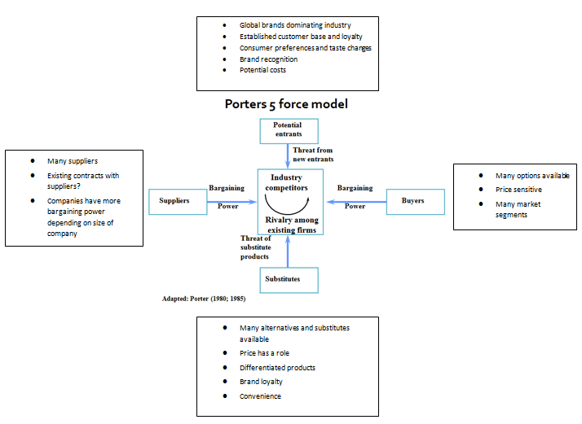
Five Forces

Figure 2 (from earlier in report): Five Forces model (Porter, 1980;1985)

Potential Entrants
The threat of new entrants into the food industry is medium. The fast food industry is dominated by huge corporations and brands that have been established for decades. This foundation in the fast food industry has caused these brands to establish a loyal customer base and create a brand image that is known globally. The opportunity; however, exists for companies that have a unique offering to come into the fast food market although these unique product offerings must be parallel with consumer preferences. Therefore, the threat of new entrants into the fast food industry is a possibility if there becomes a want for new food options or the adoption of a new brand becomes a trend.
Buyers
The bargaining power of buyers is extremely high due to various factors. Consumers possess the ability to choose from countless fast food suppliers that are in their country’s market segment. This means that consumers control the buying and purchasing process based on their needs and wants. These needs and wants may stay the same over an extended amount of time or may vary frequently. Consumers can control how much they are willing to spend on a given product which also gives them control and even more bargaining power (Wilkinson, 2013).The amount of money spent can also be influenced by the quality of food, service, or the environment. The quality factor is a major determinant of brand loyalty. Brand loyalty is achieved when consumers make a deliberate purchase from a brand repeatedly. Brand loyalty drives business in order to achieve financial success and growth (Investopedia, 2010).
Suppliers
The bargaining power of suppliers is low. There are such large numbers of suppliers for the inputs needed by fast food companies, that changing suppliers would not be difficult or change production at all. The only bargaining power a supplier would possess is if a supplier had a contract with a certain business and/or brand. In this case, a supplier could use their power of controlling prices of their products against a business. However, this is only circumstantial and depends upon the terms of contracts that have been negotiated between businesses.
Substitutes
The threat of substitutes is very high in the fast food industry. The variety of foods and prices available to consumers is enormous. A consumer’s income level or disposition could determine their purchase decision. Also, brand loyalty is affected by the threat of substitutes. The strength of a particular business’s brand loyalty could play a role in the choice made by a consumer. If the brand loyalty is low, then price could be an important factor in a purchase decision. Price sensitivity has been more apparent lately due to the economic recession and unemployment in different parts of the world. Therefore, economic situations are more likely to be considered when debating on making a purchase than the allegiance to a specific brand.
Rivalry
Rivalry in the fast food industry is very high. Brands are extremely competitive to gain and retain customers. Many fast food brands launch promotions to combat other brands promotional offers. Developing a successful marketing mix is the key to becoming a major player in any industry, let alone the fast food industry. The 4Ps of the marketing mix are product, promotion, price, and place. Product refers to the items being offered by a business to its consumers. Products could range from physical goods to services to the environment or sense of community a brand builds. Promotions are the specials, deals, or traits that set brands apart from each other. Prices are the monetary value assigned to a product. Lastly, Place is the location of a business. Location is vital to gaining customers from the segment being sought. For instance the footfall achieved from a store in an urban area is completely different than the traffic and demographics achieved by a store in a suburban or rural setting.
  - Appendix 2
SWOT
Strengths  - Brand image is excellent amongst loyal customers and in the industry  - Culturally adaptive (i.e. to the Filipinos)  - Family and customer focused  - Continued financial success  - Dominant chain in Philippines  - Niche market is defined | Weaknesses  - Dependent on Filipino population  - No base in Europe  - Global presence not on par with competitors such as McDonalds or Yum! Brand
Opportunities  - Grow globally  - Social media marketing/use of technology  - Unique product offerings/ being different than major global brands such as McDonalds. | Threats  - Competitors  - Bargaining power of consumers  - Health epidemics such as obesity
Figure 2 (from earlier in report): SWOT Analysis main points
Strengths
Jollibee’s strengths are what have set them apart from the competition in the Philippines. Their brand image and loyal customers are the top strengths this firm possesses. Jollibee has been able to channel and adapt to the Filipino community so effortlessly, mainly because that is where Jollibee Foods Corporation is based. Having firsthand knowledge of the demographic being sought is essential to achieving success in such a competitive and ruthless industry. Jollibee’s values on family, the customer, and quality (Jollibee a) align itself with the values Filipinos hold dear. Filipinos are deeply rooted in the family and hold the family and community at the center of the social structure (Kwintessential, 2014). The Filipino community is collectivist. Collectivist values center on the group as a whole, not individuals. “. In these societies, kinship ties are much stronger and may take precedence over expertise in matters of appointments and promotions. Collectivism is a value in Asian, African, as well as South American cultures.” (Iowa State University, 2014). There are four components of Filipino values that drive behavior: Utang na loob, Hiya, Amor propio, Pakikisama and Pakiramdam (Garrote-Trinidad, R.N., 2014). Utang na loob means “internal debt” which has to do with being kind and helpful to others; it is a Filipino take on the concept of karma (Punsalan Castillo, 2011). Hiya is a sense of shame; hiya “drives the individual to reciprocate any real of perceived favor or service; this value drives children to care for their elderly” (Garrote-Trinidad, R.N., 2014). Amor propro is self-esteem and a feeling of pride in oneself (Lexipedia.com, 2014). Lastly, Pakikisama and Pakiramdam is the development of interpersonal relations; these two concepts drive the individual to protect his/her social relations with the closest and dear to him/her (Garrote-Trinidad, R.N., 2014). The use of all these culturally specific traits to the Filipino community has helped Jollibee achieve immense success in their country of origin as well as reputation amongst the Filipinos worldwide. This positive and strong reputation has led to continued financial success for Jollibee. As summarized from Bloomberg BusinessWeek, Jollibee has impressively improved their financials in a relatively short amount of time. “Year over year, Jollibee Foods Corp. has been able to grow revenues from $62.6B PHP to $71.1B PHP. Most impressively, the company has been able to reduce the percentage of sales devoted to cost of goods sold from 84.36% to 84.21%. This was a driver that led to a bottom line growth from $3.2B PHP to $3.7B PHP” (Bloomberg Businessweek, 2014a). What this basically means is that Jollibee is increasing their revenues, and decreasing their costs. Yes, increasing revenues also means increasing liabilities, but that is a given with changes in income and company size. Another financial strength that Jollibee has achieved is its equity and retained earnings. Retained earnings have continually increased over the course of the past four reporting periods as well as equity (Bloomsberg Businessweek, 2014b).
Table 2: Image of Jollibee’s annual revenues from the past 4 financial reporting periods (Bloomberg Businessweek, 2014b).
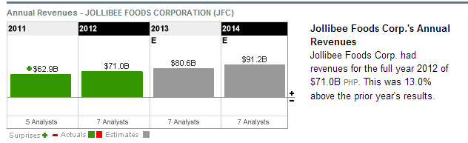

Weaknesses

Weaknesses
The major weaknesses surrounding Jollibee are also its biggest strength—the Filipino population. Jollibee’s success is due to the loyalty and commitment that the Filipino people give towards its brand. As stated earlier in the report, the Philippines ranked 16th and 18th for nationality and country of origin in terms of demographics for the entire United Kingdom. With this in mind, it is questionable as to whether Jollibee could succeed in a segment where there is not many Filipino consumers. Now compare the demographics of the United Kingdom to the United States. According to the U.S. Census Bureau, “Filipinos are now the second largest Asian group in the United States, according to the latest census bureau report”
(Filipinos 2nd largest Asian group in US, census shows, 2012). “Filipinos are the largest Asian group in the states of Alaska, Arizona, California, Hawaii, Idaho, Montana, Nevada, New Mexico, Washington, Wyoming and South Dakota. The Chinese made up the largest Asian group in Colorado, Oregon, Utah, District of Columbia, North Dakota, Maine, Massachusetts, New York, Rhode Island and Vermont. “(Filipinos 2nd largest Asian group in US, census shows, 2012).
Another weakness is that Jollibee does not have a base in Europe at all. Jollibee has locations in the Philippines, the United States, Saudi Arabia, etc… but not a single location in Europe. “In total, Jollibee has 97 stores outside of the Philippines, including those in the United States.” (Torrijos, 2013). If Jollibee is to consider entering the UK market, then having insight into European cultures would be imperative since they are a corporation consisting solely of Filipino executives. “For the Filipino market, we just have to do our job very well and it’s there. For the others you have to go beyond that. You have to build a brand because they don’t know anything about it.” (Billionaire Tony Tan Caktiong Takes Jollibee Foods Global, 2013). Tam’s response to being questioned about building a presence in Europe was this, “So it’s a matter of internal capability and whether we have the people and support team. Right now we have not focused there yet.” (Billionaire Tony Tan Caktiong Takes Jollibee Foods Global, 2013).
Lastly, Jollibee’s presence in the global sector of fast food is not yet on part with that of competitors, such as McDonalds or Yum! Brand. “In 2012, the top four global players, all based in the US (McDonalds', Yum! Brands, Doctor's Associates, and Burger King) accounted for approximately 23.5% of the available market share.” (De Angelis, 2013). “Subway is one of the fastest growing franchises in the world with approximately 39,129 restaurants in 90 countries as of May 2009, the first non-US location opening in December 1984 in Bahrain. Pizza Hut is located in 97 countries, with 100 locations in China. Taco Bell has 278 restaurants located in 14 countries besides the United States.” (De Angelis, 2013). Jollibee is the top fast food chain in the Philippines and is becoming increasingly popular in the Asian market for fast food; however, their presence needs to be amped up globally if they are to become a competitor in the international market for fast food.
Opportunities
Jollibee has many opportunities that would allow the business to grow. The first opportunity Jollibee has is the chance to expand globally. One of Jollibee’s goals is to become a global brand (Jollibee Foods Corporation, 2008). With this company wide goal in mind, the opportunity of expanding internationally has never been more apparent and welcomed. Jollibee’s international locations include: the United States, Qatar, Saudi Arabia, Kuwait, Vietnam, Hong Kong, and Brunei (Jollibee, 2014c). These locations mainly focus on the Asian and Middle Eastern markets; however, there are other global locations Jollibee has not yet entered into: South America, Africa, Canada, and Europe. All these markets have different cultures and ways of life. Scandinavia, Canada, and the U.S., which Jollibee has begun to enter, are all low context fast diffusion countries; these countries are quick to adopt new products and brands. The UK along with Eastern Europe are low context slow diffusion countries; meaning their ability to adopt new products and brands are at a low level (Willis, Samli and Jacobs, 1991).
Social media use in industries of all varieties is increasingly becoming a necessity. Social media allows businesses to connect with users in an informal environment. This informal means of communication gives people a way of expressing their opinions and experiences with companies. Social media affects all levels of a business since the customers and users are able to offer suggestions or concerns on any issue they decide to post about online. Socialnomics discusses the impact of social media and its use in the business world. Socialnomics sums up the purpose of social media in one simple phrase: “word of mouth on steroids.” Social media gives brands extreme exposure that is not possible in any other medium. To further support this claim, a survey conducted by Visceral Business and Sythesio about 85 of the UK’s leading fast food brands found that numerous brands are not “engaging with their consumers and suppliers via social media, potentially impacting brand loyalty and repeat purchases” (New Study: Fast Food Brands Falling Short on Social Media, 2013). Synthesio’s study also reported the following finding:
“Food brands seem to be spending most of their time and efforts online pushing out one-way promotional information and setting up social ways to carry out transactions, rather than building long-lasting relationships with their customers and communities through two-way engagement and real time customer service” (New Study: Fast Food Brands Falling Short on Social Media, 2013).
Knowing the impact social media has on brand loyalty and customer relationships is an opportunity that all business in any industry should all be aware of. Along with social media, comes the use of mobile devices. Mobile devices are becoming a widespread requirement. Oxfam reported that “nine out of ten people [in the United Kingdom] own a mobile phone (36 per cent in 2000, 91 per cent in 2011) – and one in seven households are now mobile-only, as the penetration of landlines dropped from 93 per cent in 2000 to 81 per cent in 2011” (Communications Market Report: A Nation Addicted to Smartphones, 2011). Statistics about phones and phone use in the UK were also reported by Oxfam in the figure below.
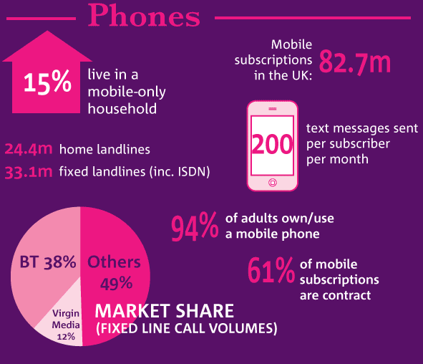

Figure 6: Statistics about phones and phone usage in the UK (Communications Market Report: A Nation Addicted to Smartphones, 2011).
Another opportunity that Jollibee has is offering unique products compared to that of its competitors. Jollibee’s products all possess a cultural flair adapted to the tastes of the Filipino population. As stated in Jollibee’s 2008 annual report, Jollibee is committed to adapting to foreign tastes and preferences and sees it as a part of growth (Jollibee Foods Corporation, 2008). In conjunction with Jollibee’s commitment to change, the UK is changing its tastes in fast food preferences. The Dailymail reported that fish and chips are no longer the fast food of choice for Brits. As seen in the figure below, Asian foods are topping the UK’s list for favorite takeaway options (McCann, 2014). This means people are becoming more open to other cultures and accepting them into their lives
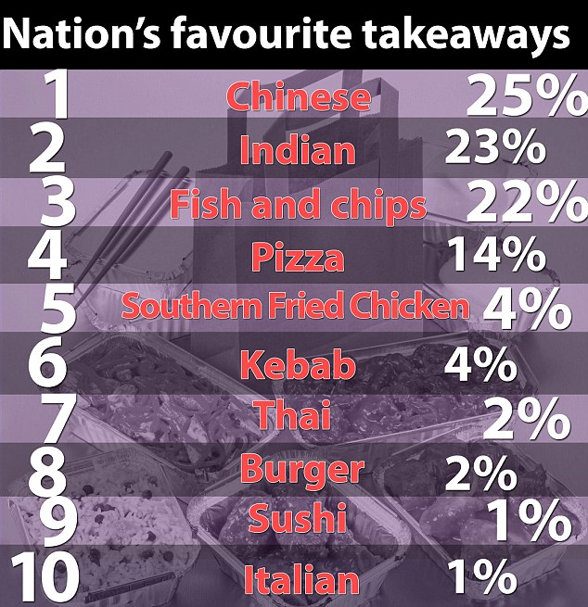

Figure 7: Ranking of the top food varieties in the UK (McCann, 2014).

Threats
A major threat being faced by Jollibee is the bargaining power of consumers and the amount of competitors that are in the fast food industry. Consumers have many options at their disposal for whatever need they may have. This is apparent in the fast food industry that Jollibee is a part of. “Figures from 2012 suggest that, rather than cutting back on eating out, consumers have reduced spend in other areas in order to make sure they can still regularly dine at restaurants and pubs.” (De Angelis, 2013). Yahoo Finance also reported the top ten restaurant chains within the United Kingdom. The top chains are: McDonalds, Wetherspoon, Greggs, KFC, Costa Coffee, Starbucks, Pizza Hut, Domino’s Pizza, Subway, and Nandos (De Angelis, 2013). This list shows that the tastes of consumers vary depending on the individual’s preferences. From pizza to coffee, consumers can take their pick of the restaurant or fast food chain that will provide them with their products. This coincides with the point that competitors are a major threat to Jollibee. Jollibee has a huge presence in the Philippines as well as an expanding presence throughout Asia and the Middle East. With their brand being concentrated in these specific market segments, globally the Jollibee brand is unknown and therefore not seen as a global competitor. Brands such as McDonalds possess a huge market share of the entire fast food industry. McDonalds has “more than 35,000 local restaurants serving nearly 70 million people in more than 100 countries each day” (About McDonalds, 2014). Comparing this to Jollibee who only exists in a few countries outside of the Philippines with roughly 830 stores open worldwide, Jollibee is not even a quarter the size of McDonalds in terms of number of stores that are open to consumers.
Another threat to Jollibee is obesity. As stated before, obesity is an issue being faced by massive amounts of people everywhere. More people are choosing unhealthy eating options than ever before. The Daily Mail reported that “More than half of all meals eaten out in Britain are – for the first time – from fast food restaurants” (Poulter, 2012). The issue with this statistic is the quality of food from fast food restaurants is so poor. Fast food restaurants supply food with low nutritional value, high sugar levels, and high caloric levels. “The larger portion sizes, higher energy densities, high fat content, and low prices of fast foods are hypothesized to be causally related to rising obesity rates” (Moore and Diaz Roux et al., 2009, pp. 29-36). An excerpt from an info graphic provided by Coca Cola lays out a few statistics about intake of calories. However, Coca Cola is one of the problems in the obesity epidemic. Intake of high caloric, sugary drinks is another factor in the increasing obesity rates. Harvard School of Public Health released a fact sheet about the effects of sugary drink intake on the American population. “Sugary drinks increase the risk of obesity, diabetes, heart disease, and gout” (Harvard School of Public Health, n.d.).
“A 20-year study on 120,000 men and women found that people who increased their sugary drink consumption by one 12-ounce serving per day gained more weight over time—on average, an extra pound every 4 years—than people who did not change their intake. Other studies have found a significant link between sugary drink consumption and weight gain in children. One study found that for each additional 12-ounce soda children consumed each day, the odds of becoming obese increased by 60% during 1½ years of follow-up” (Harvard School of Public Health, 2014).
The intake of high caloric, sugary foods and its effect on health is staggering. If this trend continues, other aspects of society will be affected by obesity and health concerns—the economy due to spending on health care as well as the government who will have to get involved with the regulation of foods offered and marketed to its citizens.

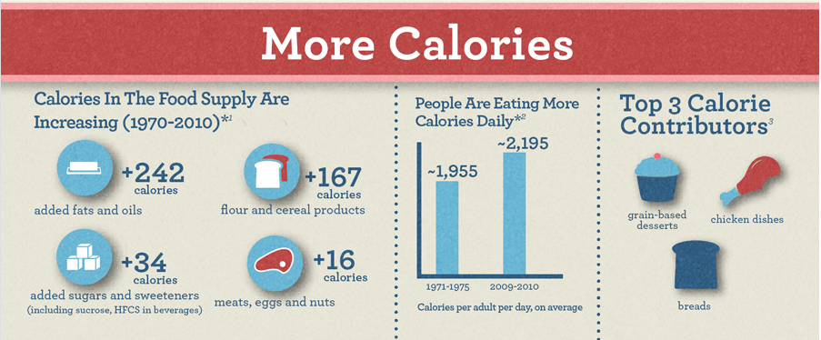
Figure 8: Statistics about caloric intake (The Coca Cola Company, n.d)
  - Appendix 3
Porter’s Generic Strategies
Jollibee practices the focused differentiation approach. This means that Jollibee is targeting a specific segment of the population with special needs and wants. The specific group Jollibee is targeting is the Filipino Population. Tony Tam, the founder of Jollibee decided to make Jollibee a source of Filipino pride (ICMR, 2003). Jollibee tailors its food and menu to the Filipino tastes. “All the food products were prepared keeping in mind the tastes and flavors prevalent in the country” (ICMR, 2003).
  - Appendix 4
Lifecycle
When applying the product life cycle to analyze the state of companies, it appears that Jollibee is in the growth stage of the product life cycle. This means that Jollibee had to move past the introduction stage. The introduction stage is where products or brands are introduced into a market. Brand awareness and is essentially the main goal of this stage. Two ways to introduce a product are penetration and skimming pricing strategies.
“In the new product development literature, new product pricing is often represented as a choice between market penetration pricing, in which a low price attempts to stimulate product adoption, and market skimming, in which the market segment with the highest reference price is targeted first, and the market is subsequently skimmed to capture segments with lower reference prices” (Paul T. M. Ingenbleek, Ruud T. Frambach and Theo M. M. Verhallen Best Practices for New Product Pricing: Impact on Market Performance and Price Level under Different Conditions Journal of Product Innovation Management 30). “
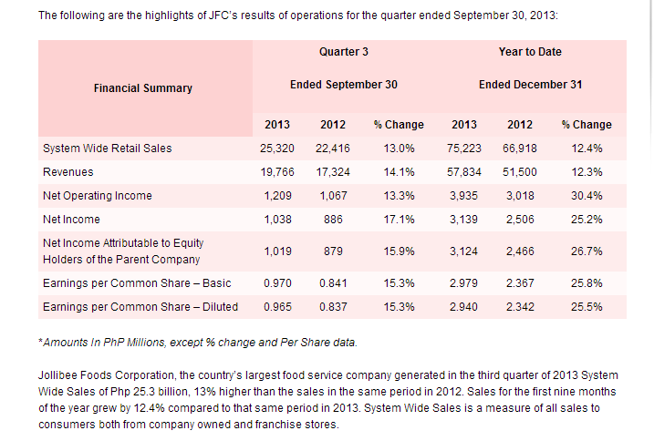
Since Jollibee has surpassed this stage, this means the public has accepted their product. During the growth stage a business grows and experiences a surge in sales. This is supported by the financial statements of Jollibee. Jollibee’s financial statements over the past few financial reporting periods all show growth and increases in revenue.

Table 3: Highlights of Jollibee’s finances (Jollibee, 2014d)
These figures provided by Jollibee’s page for potential investors clearly show that Jollibee is experiencing economic prosperity. The most impressive number featured on this excerpt from the financial statements of Jollibee is the percent change in net income. Jollibee managed to increase their net come in one year by more than 25%.
  - Appendix 5
PESTLE expanded

Figure 1: main points of PESTLE reevaluated

Political/ Legal
The United Kingdom has many laws and regulations regarding food. The Food Standards Agency is the department responsible for implementing and regulating food safety and hygiene standards across the UK. (Food Standards Agency, 2014a). The Food Standards Agency works with businesses to help them produce safe food, and with local authorities to enforce food safety regulations” (Food Standards Agency, 2014a). The Food Safety Act of 1990 “provides the framework for all food legislation in Great Britain – similar legislation applies in Northern Ireland” (Food Standards Agency, 2014b). Legislation for food also comes from the European Union. This means that food standards are essentially the same for the members of the European Union. The Codex is another major source of food regulation. The Codex is a sequence of international standards for food and agricultural products. They help ensure fair trade and consumer protection internationally (Food Standards Agency, 2014c). The standards from the Codex are voluntary, meaning there is no obligation to follow them. However, the Codex is recognized by the World Trade Organization and sponsored by the World Health Organization as well as the Food and Agriculture Organization (Food Standards Agency, 2014c). In addition to these acts and agencies regulating and protecting consumers in the various food industries, the UK government implemented a responsibility deal with around 500 collaborators. This deal has helped food businesses cut down on the amount of sugar, fat, and salt used in their food products (Boseley and Campbell, 2013). Addressing the last point in the legal column in figure 1, many food companies have established contracts with suppliers and manufacturers. This means there is a contractual obligation to follow the terms agreed upon in the contract. Failure to comply to a contract would be considered a breach of contract and could result in legal action depending on the severity of the breach.
Economic
Recent years have given way to many economic situations within the UK as well as the world. Ever since the economic recession of 2007/2008, countries have been dealing with economic crises which has been affecting trade, employment, and spending. “Governments reacted by creating huge stimulus packages that greatly increased national deficits and debts, and by loosening monetary policies with interest rates close to zero and huge expansions of the money supply. In their efforts to save the financial system, governments also offered bail-out packages to banks, including loans, guarantees and equity” (Cadieux and Conklin, 2010). However, things are starting to turn around for the UK. “Britain's economy grew at the strongest rate in six years in 2013, as recovery from the longest financial crisis in a century became more established” (Monaghan, 2014). Despite this positive headline, all is not completely well in Britain. “The Office for National Statistics said real wages had fallen by 2.2% annually since the first three months of 2010” (BBC News, 2013). Since wages are falling for some of the population, spending has been fluctuating. Consumers are more price sensitive than before the recession and want to get the most value from the money they choose to spend. Being aware of money spent is reflected in the increase on spending that has been occurring in the fast food industry. “It’s a lot about trading down. Because fast food has become so cheap, it has driven families in particular from independent restaurants and pubs to fast food chains” (Poulter, 2012).
Social
Healthy lifestyle trends have been on the rise worldwide over the course of the past few years. From choosing to buy ethically produced items, to inducing environmentally friendly choices, global citizens are becoming more aware of the impact of their daily decisions.
“A quarter of UK consumers said they would take the green option even if it cost them more money, up from eight per cent 17 months earlier, according to a survey by Nielsen, the market research company. The UK trend reflects a global surge in interest in environmentally friendly products with the proportion of consumers prepared to pay more to protect the natural world more than doubling to 46 per cent last autumn from 22 per cent in spring 2011, according to Nielsen” (Butler, 2013).
Another aspect of being environmentally conscious is being ethical in the use of the resources. Many fast food chains have made headlines over the years due to unethical exploitation of resources. A major source of exploitation within the fast food industry is exploitation of employees. “A study into the prevalence of minimum wage abuses recently commissioned by Newham and carried out by Mori and the local charity Community Links pointed out that employees are often "actively complicit in hiding their employers' malpractice because they want to protect their jobs". Despite this trend of having job security over a living wage, many fast food employees do not want to live at or below poverty. Some fast food employees recently went on strike in Chicago (United States) to combat such incredibly low wages. As one striker put it, “yesterday I got paid; today I have not a dollar in my pocket.” ( ) In response to this strike which encompassed the entire city of Chicago, the president of the United States of America, Barrack Obama, made a vow to improve wages for U.S. workers. President Barrack “called for the federal rate to be increased in his speech on Wednesday, specifically mentioning fast-food and retail workers. ‘I'm going to keep pushing until we get a higher minimum wage for hard-working Americans across the entire country. It will be good for our economy. It will be good for our families,’ he said” (Gabbatt, 2013).
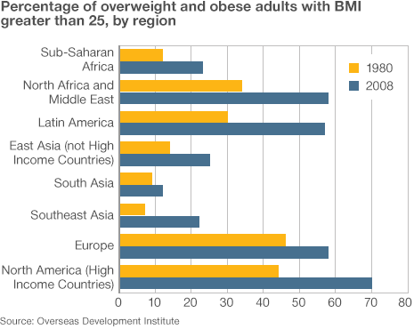
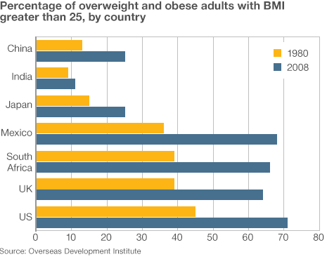
Another issue being faced globally is obesity. Merriam-Webster defines obesity as “a condition characterized by the excessive accumulation and storage of fat in the body” (Merriam-Webster, 2014). Obesity has nearly doubled since the 1980s and is now the fifth leading risk for global death (World Health Organization, 2014). Obesity is one of the most common health risks being faced around the world due to the other health concerns that arise as a result of being overweight; these additional health concerns consist of diabetes, cardiovascular diseases, and cancer (World Health Organization, 2014)This is a staggering statistic considering more than half of the population is increasing their chances for health risks, complications, and diseases, all due to being overweight and making unhealthy choices.

Figure 9: Percentage of obesity prevalence by country (Gentleman, 2012)
Technological

The role of technology is increasing in importance for everyone around the world. For both personal and business use, technology is making life easier in all aspects. The internet has eradicated the barrier between businesses and consumers, making international trade a daily occurrence. “The majority of homes are now connected to the internet (25 per cent in 2000, 76 per cent in 2011)” (Communications Market Report: A Nation Addicted to Smartphones, 2011). Since accessing the internet is increasing, the use of internet ordering and trade has also been increasing. Online ordering is popular for sales of clothing, home accessories, or anything being sought. “Britain is the biggest online shopping nation in the developed world, with almost two-thirds of adults using the internet to buy goods or services.” (Hall, 2012). Despite the fact that Britons are using the internet to shop more frequently than other developed nations, it was found that UK businesses are very slow at embracing the use of the internet (Hall, 2012). “The UK has the fifth lowest number of businesses that use the internet in the developed world” (Hall, 2012).

In addition to the internet aiding trade, the internet is allowing companies to connect with their customers via social media. Merriam Webster defines social media as “forms of electronic communication (as Web sites for social networking and microblogging) through which users create online communities to share information, ideas, personal messages, and other content (as videos)” (Merriam-Webster, 2014b). Social media use has exploded in the past few years thanks to social media sites such as Facebook, Twitter, Instagram, and Pinterest. It has been reported that the British are amongst the top users of social media in all of Europe. “In 2012, the UK was placed second out of all EU countries accessing social networks from mobile devices” (Woolaston, 2013). “Almost half of all adults in the UK - 48 per cent - used social networking sites in 2012” (Woolaston, 2013). With this in mind, connecting to consumers on mobile devices and social media is key. According to a survey conducted by Forbes, respondents said it’s important for restaurants to start using these technologies [social media] and that they expect to use technology more often in the coming year to order food (Tice, 2012).
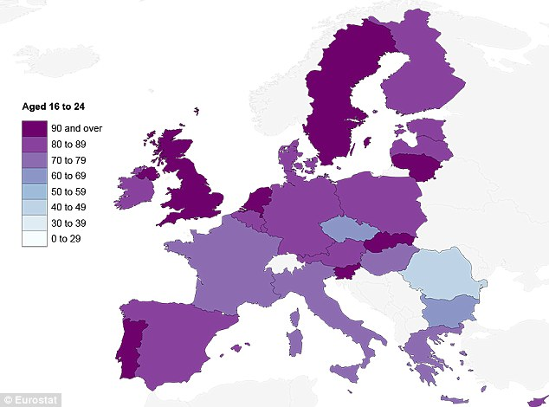

Figure 10: shows amount of people aged 16-24 who use social media on a daily basis (Woolaston, 2013)

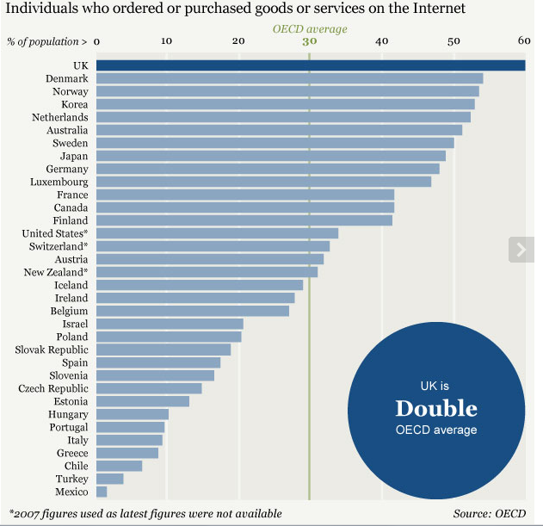

Figure 11: the figure shows the amount of goods ordered online by country (Hall, 2012)
Environmental
As defined by Oxford English Dictionary, sustainability is the conserving of an ecological balance by avoiding depletion of natural resources (Oxford English Dictionary, 2014). Sustainability is becoming a concern everywhere in order to conserve and protect the Earth’s natural resources and environment. “The new coalition government [in the UK] is committed to being the greenest government ever. It is taking action to cut carbon emissions, create the conditions for green growth, and improve resilience to climate change – all of which is necessary for delivering sustainable development and long term economic growth” (European Union: European Social Fund, n.d.). This is an important issue due to the steady increase in the global population. If the rate of resources being used continues at the current speed, then there could be very few resources left for future generations. “The UK’s sustainability goal, published in ‘Securing the future’ in March 2005, is to enable all people throughout the world to satisfy their basic needs and enjoy a better quality of life without compromising the quality of life of future generations” (Department for Environment, Food, and Rural Affairs, 2006). “The concept of creating and maintaining a sustainable food supply has been embraced in varying degrees by a growing number of restaurant operations, ranging from Atlanta’s two-unit Yeah! Burger to giant, worldwide chains like McDonald’s” (Wolf, 2013). Being sustainable also means being environmentally friendly. Environmentally conscious consumers are becoming aware of the impact of their lifestyle choices and its effect on the environment. “Between 2010 and 2011, the UK‟s carbon dioxide footprint fell by 5 per cent following a 1 percent rise in 2009. The carbon dioxide footprint peaked at 831 million tonnes carbon dioxide in 2004 and in 2011 was 22 per cent lower” (Department for Environment, Food, and Rural Affairs, 2013).This can be linked to consumers and governments’ awareness and actions regarding the protection and preservation of the environment.

